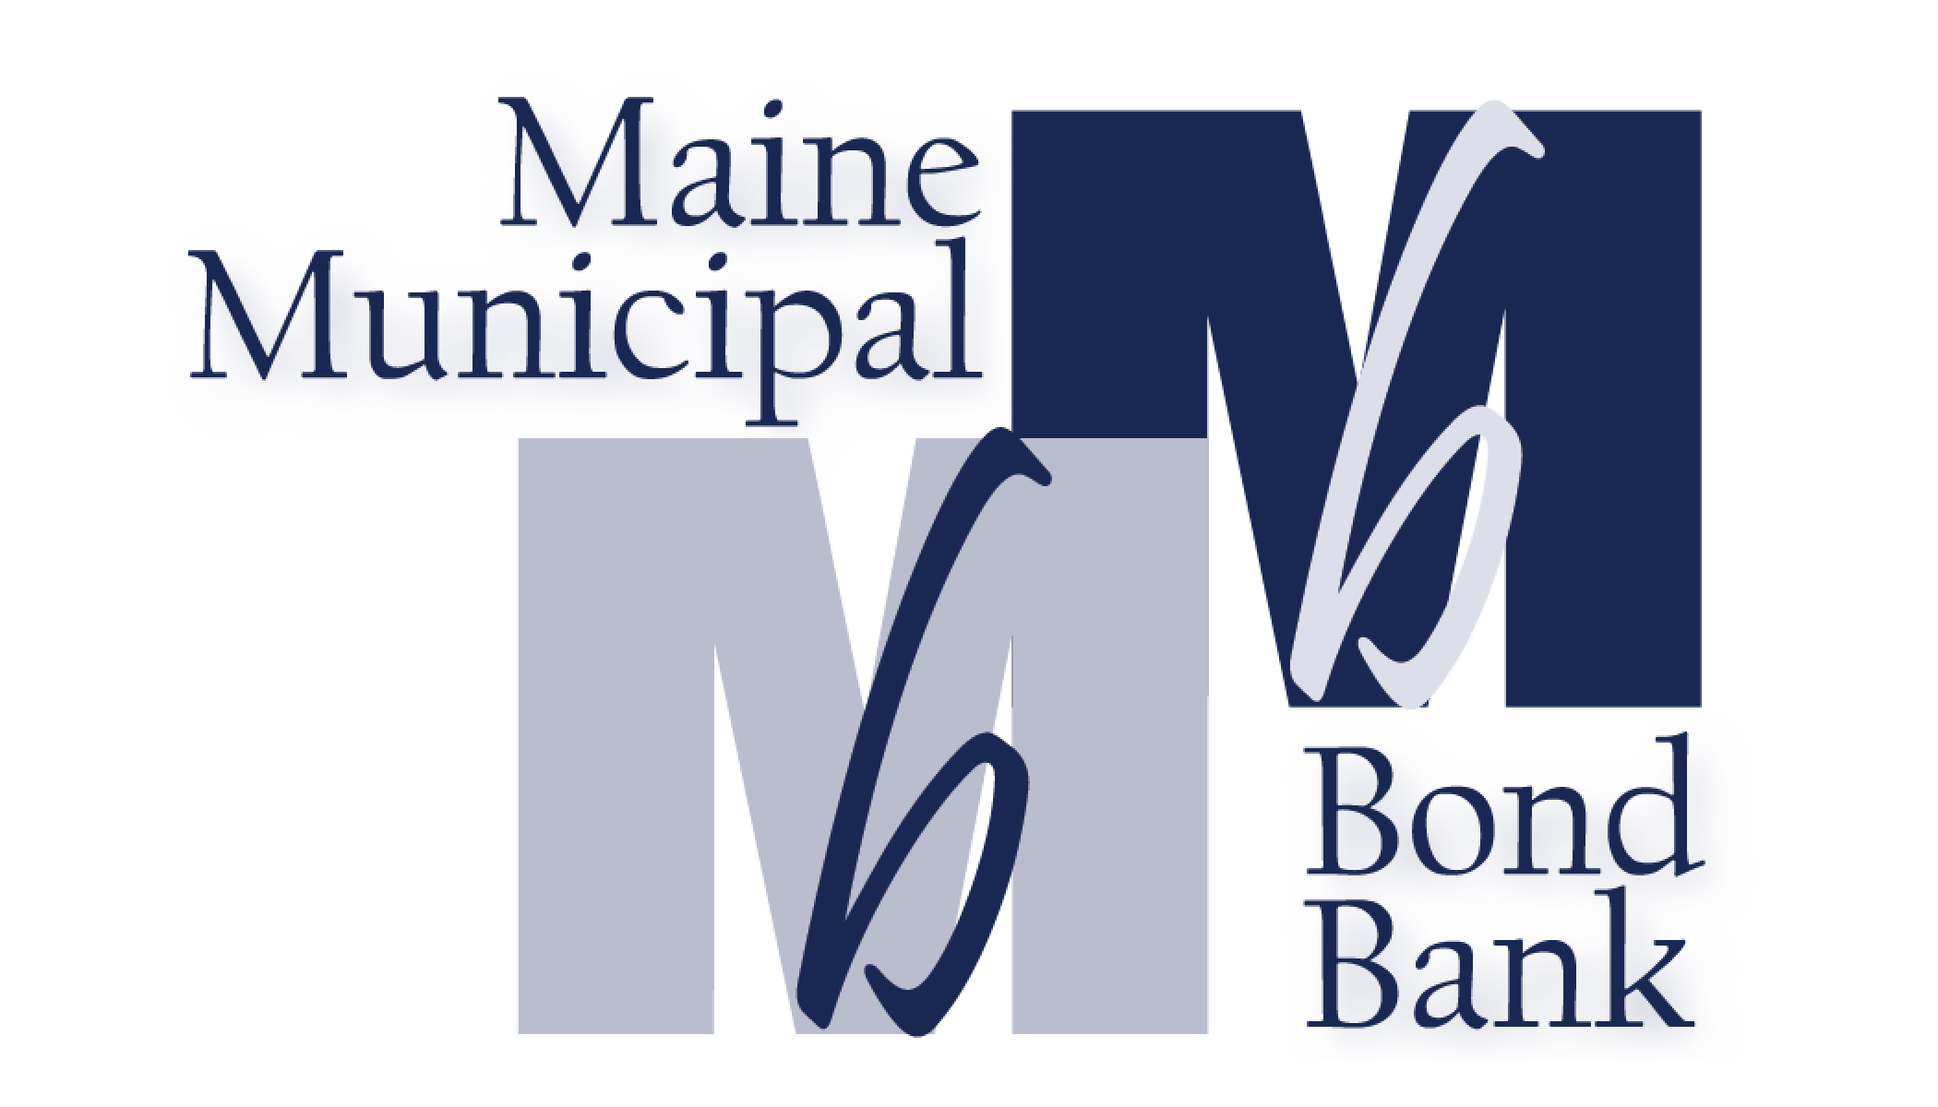

MEETING AGENDA
September 27, 2023

An annual meeting of the Maine Municipal Bond Bank has been called by Board Chair John Simko for Wednesday, September 27, 2023 at 4:00 p.m. at the Tarratine in Bangor, Maine.

Order of Business:
- Roll Call
- Reading and Approval of the Minutes of August 23, 2023
- Treasurer’s Report as of August 31, 2023 – Jill Pierce, Accountant
- Old Business:
- New Business:
Election of Officers for fiscal year 2023-2024
Appoint General Counsel for fiscal year 2023-2024
- Program Updates – Toni Reed, Kelley Wheeler, Kristi Lamoreau
- Executive Director Report – Terry Hayes
- Other
Adjourn
List of Attachments:
- Minutes of August 23, 2023
- Treasurer’s report – Jill Pierce
- SRF CIFA Write up – Kelley Wheeler
- SRF Pipeline – Kelley Wheeler
- SRF program update-closing side – Kristi Lamoreau
- Executive Director’s report – Terry Hayes
- MHHEFA Memo – Anthony Jaccarino
- MPO Memo – Kay Mann

