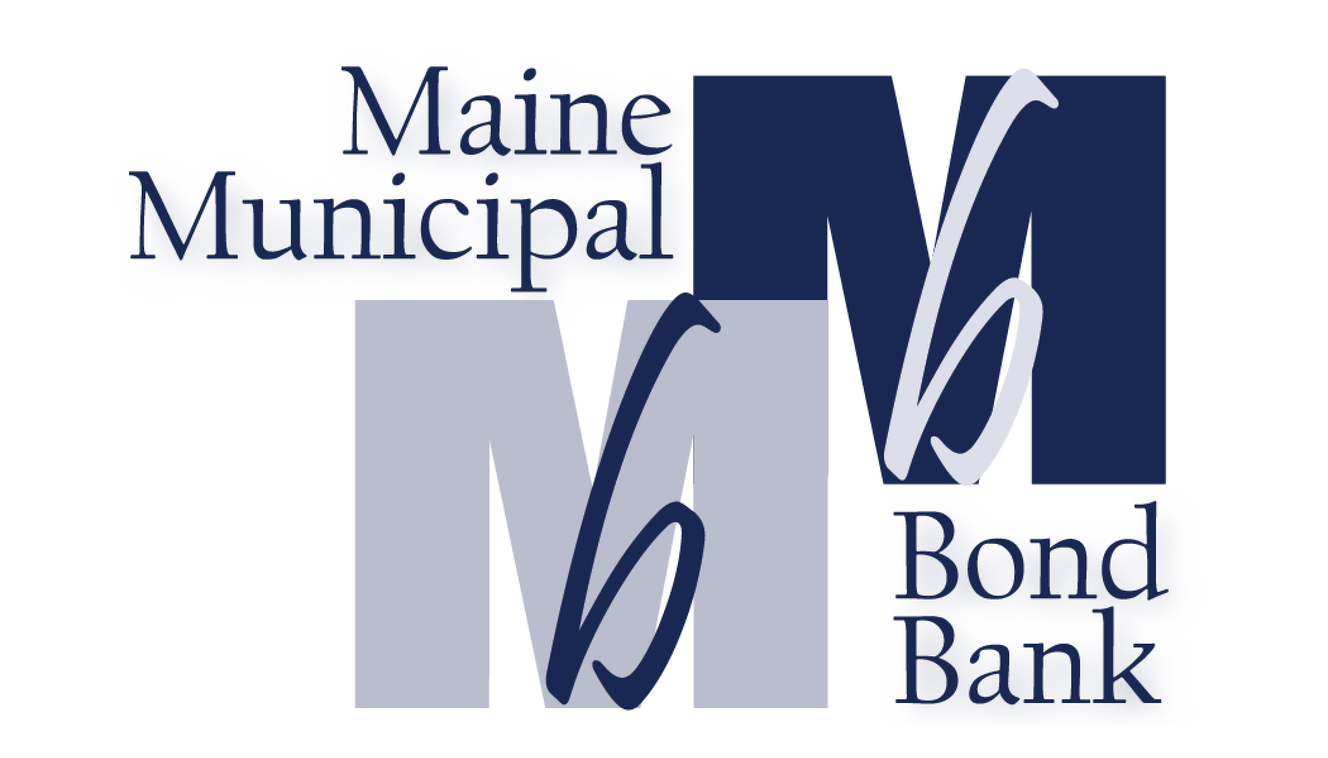

MEETING AGENDA
SEPTEMBER 27, 2023

An annual meeting of the Maine Public Utility Financing Bank has been called by Board Chair John Simko for Wednesday, September 27, 2023 immediately following the Maine Municipal Bond Bank annual meeting at 4pm at the Tarratine in Bangor, Maine.

Order of Business:

- Roll Call
- Reading and Approval of the Minutes of September 28, 2022
- Report of the Treasurer for the Month(s) of: None
- Old Business: None
- New Business:
- Election of Officers for fiscal year 2023-2024
- Appoint General Counsel for fiscal year 2023-2024
- Other:
Proposed REPEAL of the MPUFB statute – action item

Adjourn

List of Attachments:
- Minutes of September 28, 2022
- MPUFB history memo-Terry Hayes

